**Full wave and half wave rectification**

**Lab Report : 05**



**Spring 2020**

Submitted by: **Shah Raza**

Registration No: **18PWCSE1658**

Class Section: **B**

“On my honor, as a student of University of Engineering and Technology, I have neither given nor received unauthorized assistance on this academic work.”

Submitted to:

**Engr. Abdullah Hamid**

June 26, 2020

**Department of Computer Systems Engineering**

**University of Engineering and Technology, Peshawar**

**Objectives:**

To become familiar with Full wave and Half wave rectification.

**Components**

Diodes: Silicon (1N4007)

Resistor: 2.2 k Ω ,10k

Alternator

**Theory:**

**Diode:**

A diode is a two-terminal electronic component that conducts current primarily in one direction; it has low resistance in one direction, and high resistance in the other.

A widely used application of this feature and diodes in general is in the conversion of an alternating voltage (AC) into a continuous voltage (DC). In other words, *Rectification*.

Power diodes can be used individually as above or connected together to produce a variety of rectifier circuits such as “Half-Wave”, “Full-Wave” or as “Bridge Rectifiers”.

**Alternator**

Alternator is the AC source in which we set the Amplitude and Frequency of the voltage.

In this experiment we set it 220V and 50Hz Frequency.

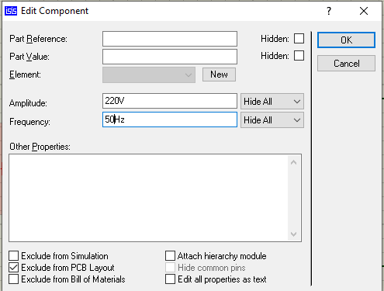

**Half Wave Rectification**

A rectifier is a circuit which converts the *Alternating Current* (AC) input power into a *Direct Current* (DC) output power. The input power supply may be either a single-phase or a multi-phase supply with the simplest of all the rectifier circuits being that of the **Half Wave Rectifier**.

The power diode in a half wave rectifier circuit passes just one half of each complete sine wave of the AC supply in order to convert it into a DC supply. Then this type of circuit is called a “half-wave” rectifier because it passes only half of the incoming AC power supply as shown.

Figure: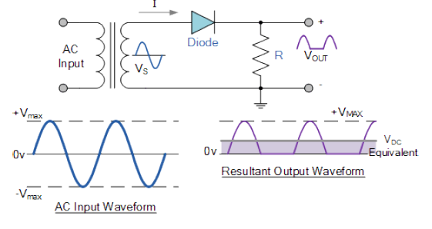

**Circuit in Proteus:** 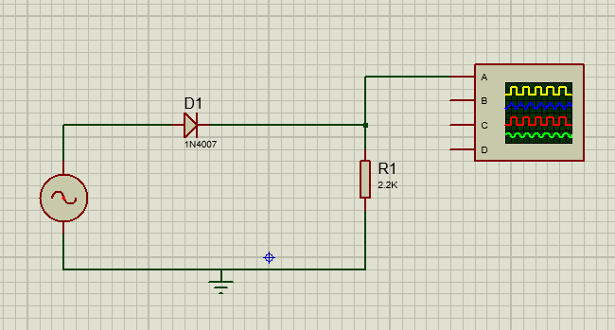

**Output :**

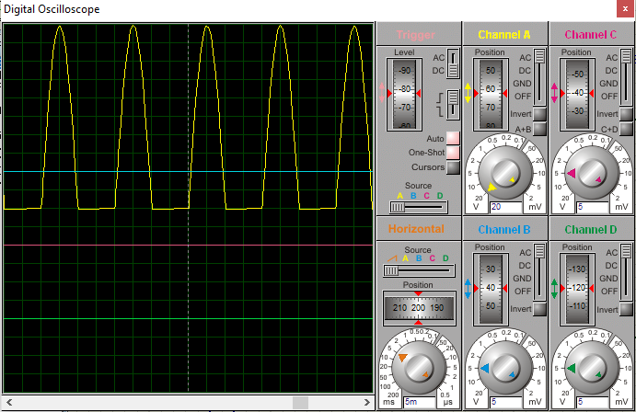

**PCB Layout:**

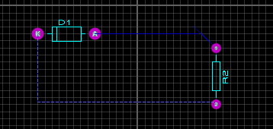

**Full Wave Rectifier Circuit**

The full wave rectifier circuit consists of two *power diodes* connected to a single load resistance (RL) with each diode taking it in turn to supply current to the load. When point A of the transformer is positive with respect to point C, diode D1 conducts in the forward direction as indicated by the arrows.

When point B is positive (in the negative half of the cycle) with respect to point C, diode D2 conducts in the forward direction and the current flowing through resistor R is in the same direction for both half-cycles. As the output voltage across the resistor R is the phasor sum of the two waveforms combined, this type of full wave rectifier circuit is also known as a “bi-phase” circuit.

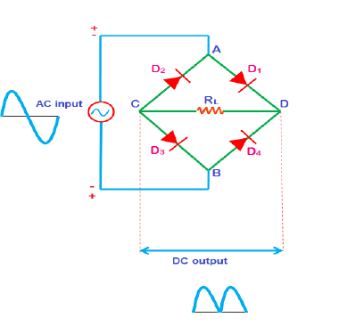

**Figure:**

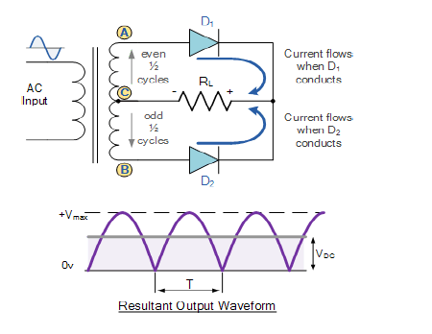

**Circuit in Proteus:**

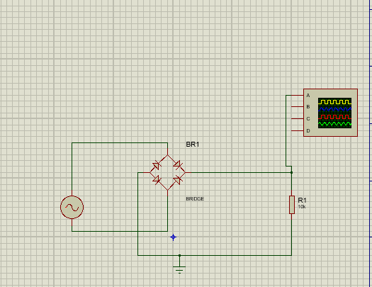

**PCB Layout:**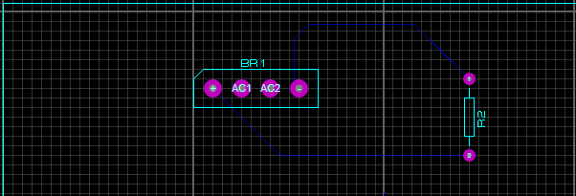

**Result on Oscilloscope:**

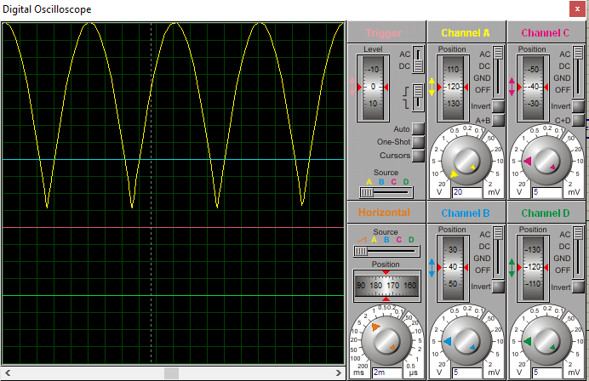

## Conclusion :

From this experiment we learned how to design a Half Wave and Full Wave rectification Circuits in Proteus and obtained the result on Oscilloscope and drew the PCB Layouts.